Week 5 Lab: Data Redaction (Dynamic Data Masking)
Data redaction and dynamic data masking serve related but distinct purposes in database security. Redaction typically refers to permanently or statically removing sensitive values from data before it is shared, for example, obscuring all but the last four digits of a credit card number in a printed report (Microsoft, 2024). Use cases include regulatory disclosures, legal discovery responses, and customer-facing exports where sensitive values must never appear regardless of who views the document. Dynamic Data Masking (DDM), by contrast, operates at query time, returning masked values to restricted users while preserving the underlying data intact for privileged accounts (Bertino & Sandhu, 2005). Common DDM use cases include customer support dashboards where agents need to verify identity without seeing full PII, developer and testing environments that require realistic data shapes without exposing production records, and multi-tier applications where only a subset of roles should see complete field values.
The most important thing I wish I had known before starting this lab is that DDM is a presentation-layer control, not a storage-layer security boundary. A user with ALTER TABLE or UNMASK permissions can bypass the mask entirely, and anyone with direct file access to the .mdf data file sees unmasked values regardless of DDM configuration (Microsoft, 2024). This means DDM should always be paired with proper role-based access controls rather than treated as a standalone protection. I also wish I had known that the EXECUTE AS USER pattern is the correct way to test masking behavior without creating a separate login; impersonating MaskingTestUser while remaining connected as DU\Grace.Luhanga made it straightforward to compare masked and unmasked results in the same session, and REVERT cleanly returned the session context to the privileged account.
Figure 1: MaskingTestUser created WITHOUT LOGIN and granted SELECT on the dbo schema
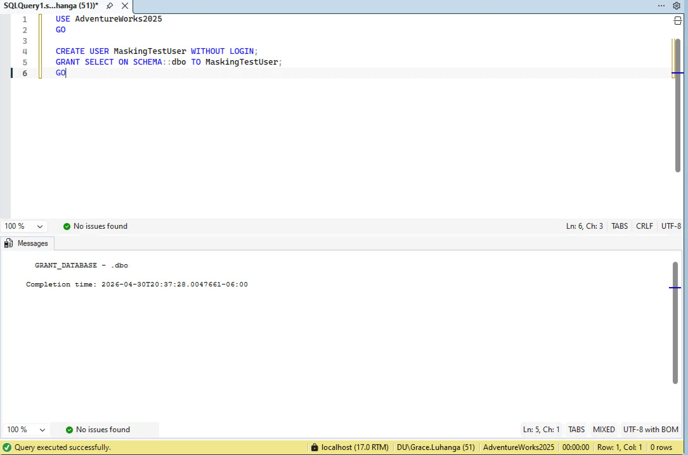

Figure 2: Admin view – full unmasked data returned for DU\Grace.Luhanga (sysadmin bypasses masking)
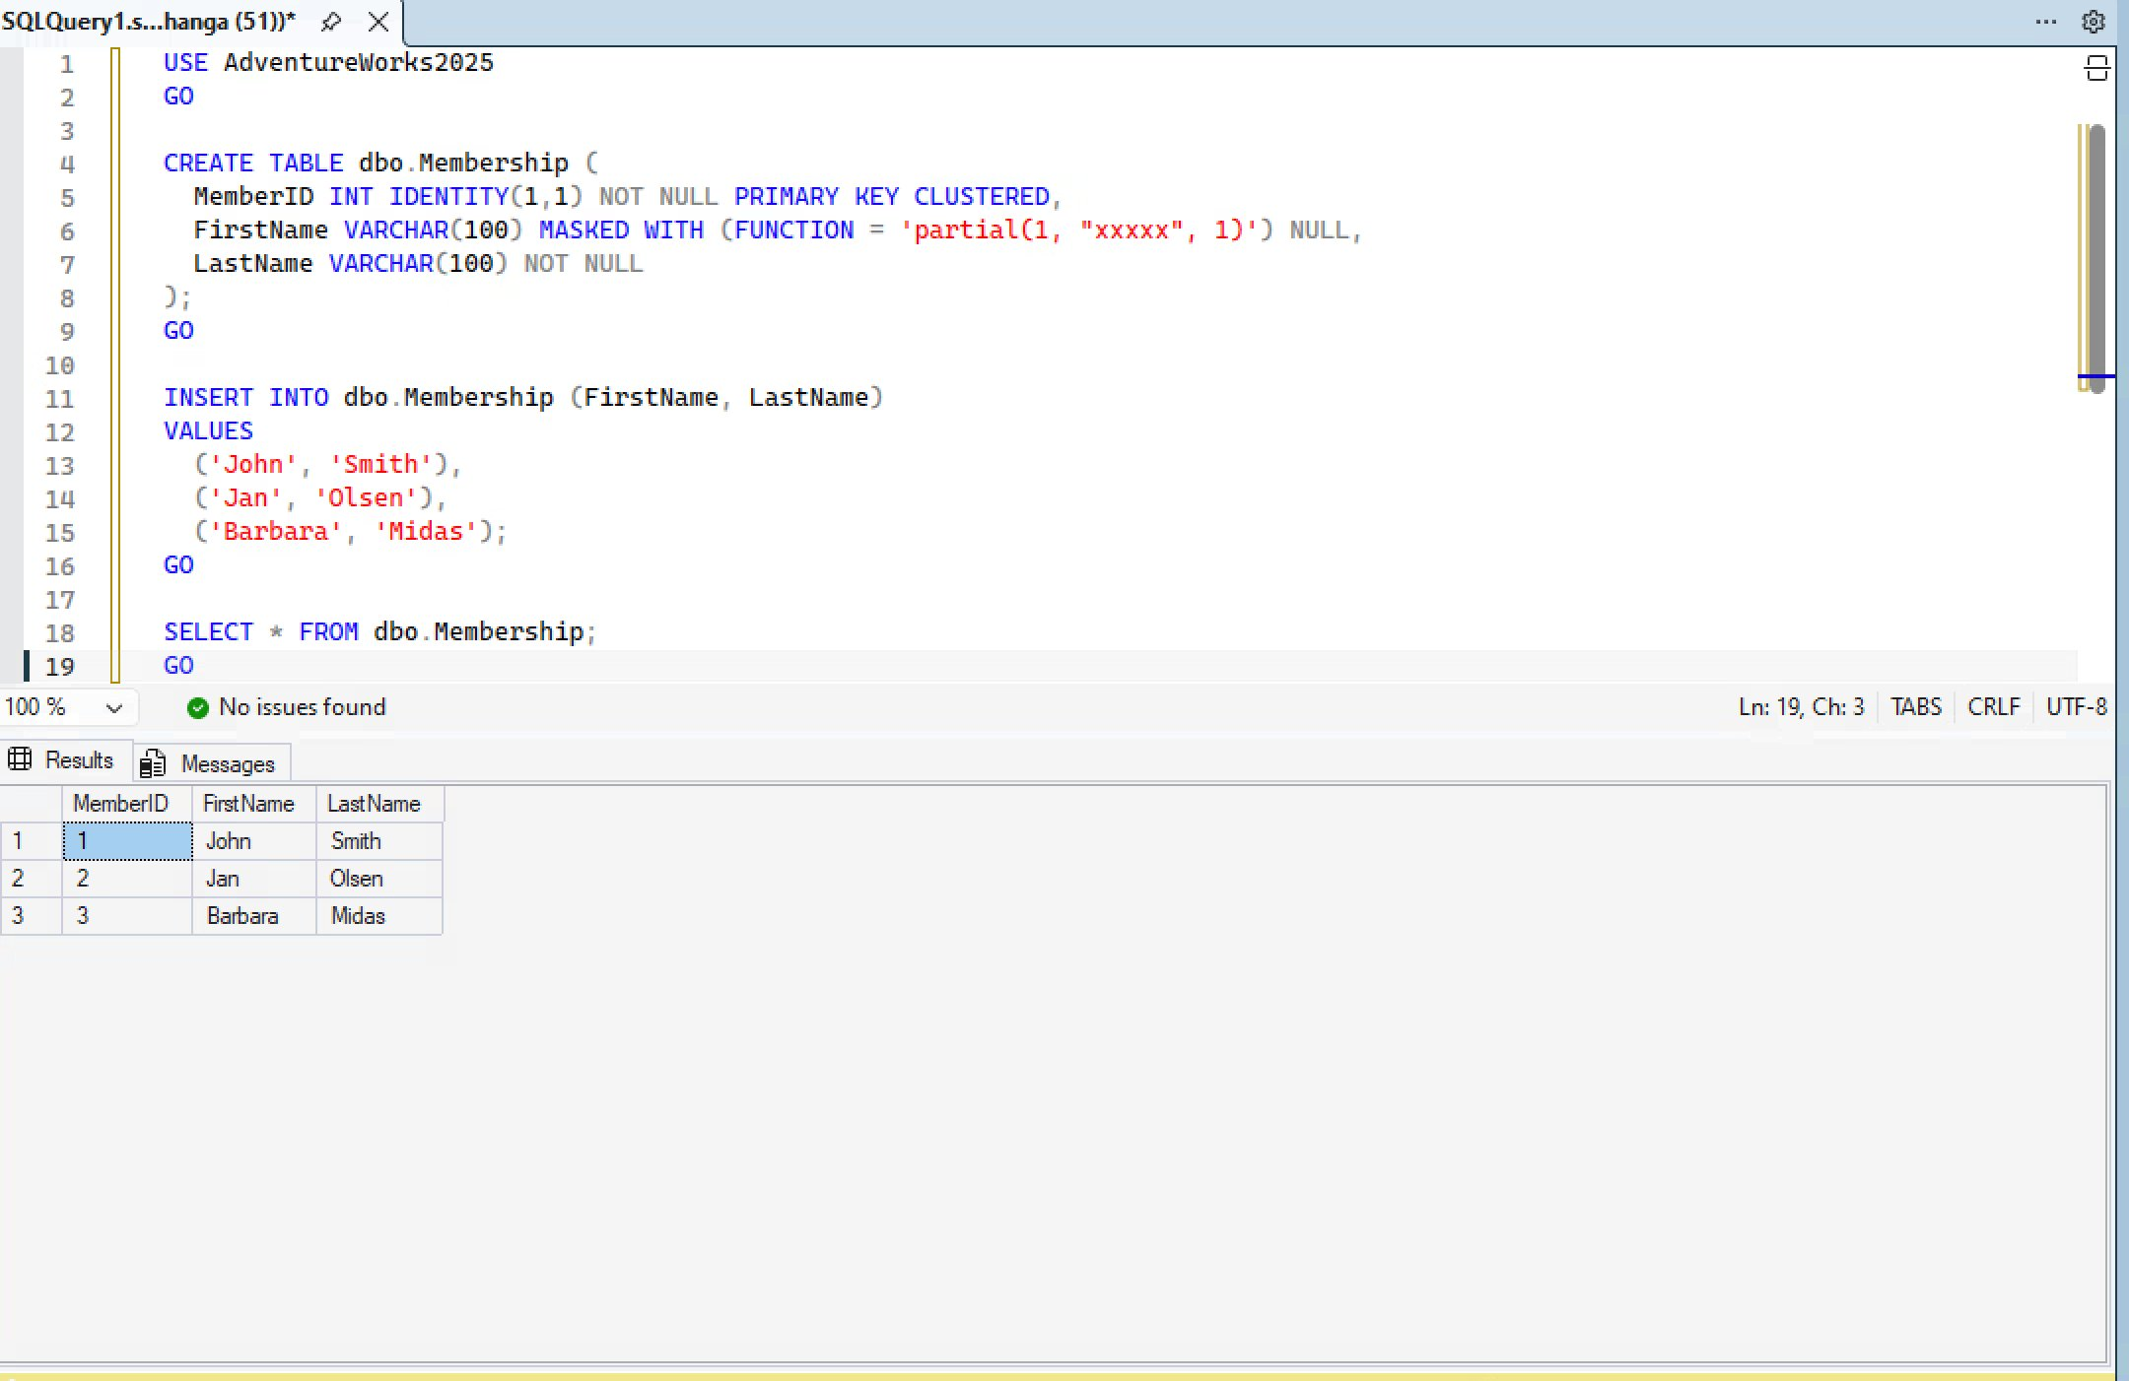

Figure 3: Masked view – FirstName column shows Jxxxn, Jxxxn, Bxxxxxa for MaskingTestUser with SELECT-only access
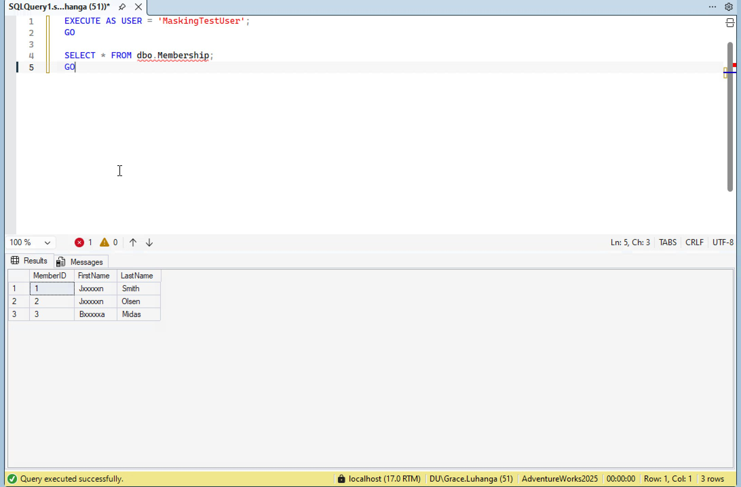

Figure 4: REVERT restores DU\Grace.Luhanga session context – full unmasked data visible again confirming admin privilege bypass
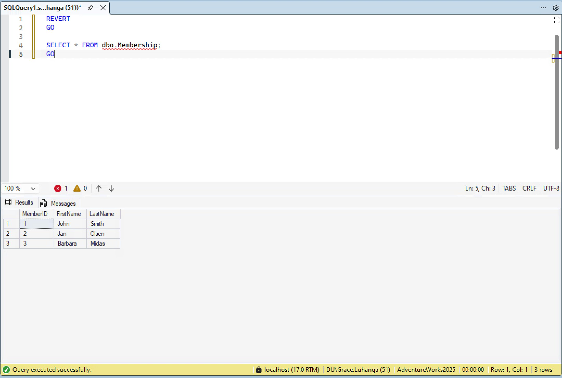
References
Bertino, E., & Sandhu, R. (2005). Database security — concepts, approaches, and challenges. IEEE Transactions on Dependable and Secure Computing, 2(1), 2–19. https://doi.org/10.1109/TDSC.2005.9
Microsoft. (2024). Dynamic data masking. Accessed April 30, 2026. https://learn.microsoft.com/en-us/sql/relational-databases/security/dynamic-data-masking

